**Smart Blind Stick**

**Abstract:**

The "Smart Blind Stick: A Navigation Aid for the Visually Impaired Using Arduino" is a cost-effective and technologically advanced solution designed to empower individuals with visual impairments in their daily mobility. The system incorporates key components, including an Arduino Uno R3 microcontroller, ultrasonic sensors, a vibration motor, a buzzer, and a PVC pipe, to create an efficient and user-friendly smart stick.

The Smart Blind Stick's construction utilizes a PVC pipe as the primary structure, offering durability and flexibility. This design choice facilitates easy handling and promotes comfort during use. The integration of these components results in a lightweight, portable, and affordable navigation aid, aiming to improve the independence and safety of visually impaired individuals.

**Block Diagram :-**

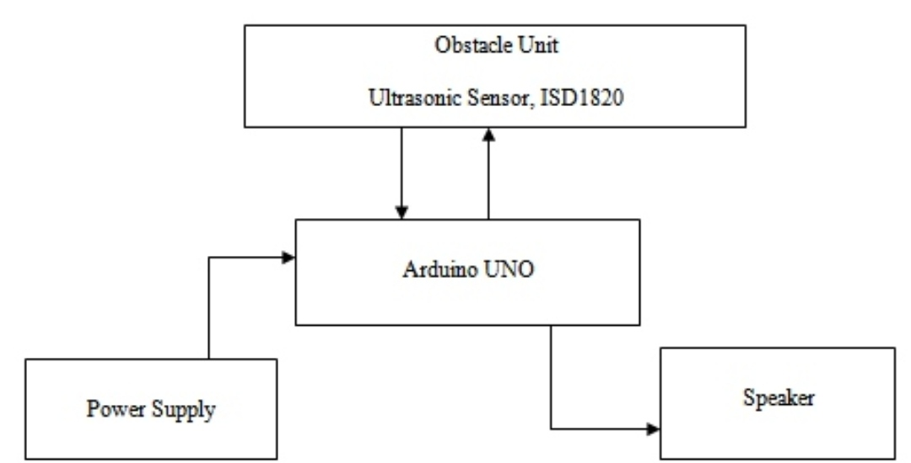

**Requirements :**

* **Arduino Uno R3**
* **Ultrasonic sensor**
* **Vibration motor & Buzzer**
* **PVC Pipe**

**Code :**

// defines pins numbers

const int trigPin = 9;

const int echoPin = 10;

const int buzzer = 11;

const int ledPin = 13;

// defines variables

long duration;

int distance;

int safetyDistance;

void setup() {

pinMode(trigPin, OUTPUT); // Sets the trigPin as an Output

pinMode(echoPin, INPUT); // Sets the echoPin as an Input

pinMode(buzzer, OUTPUT);

pinMode(ledPin, OUTPUT);

Serial.begin(9600); // Starts the serial communication

}

void loop() {

// Clears the trigPin

digitalWrite(trigPin, LOW);

delayMicroseconds(2);

// Sets the trigPin on HIGH state for 10 micro seconds

digitalWrite(trigPin, HIGH);

delayMicroseconds(10);

digitalWrite(trigPin, LOW);

// Reads the echoPin, returns the sound wave travel time in microseconds

duration = pulseIn(echoPin, HIGH);

// Calculating the distance

distance= duration*0.034/2;

safetyDistance = distance;

if (safetyDistance <= 5){

digitalWrite(buzzer, HIGH);

digitalWrite(ledPin, HIGH);

}

else{

digitalWrite(buzzer, LOW);

digitalWrite(ledPin, LOW);

}

// Prints the distance on the Serial Monitor

Serial.print("Distance: ");

Serial.println(distance);

}

Smart Stick For Bl